We present our conceptual and logical modeling in these following images. We have a Records table, which includes the record ID, the name of the user, and message number. We have separate tables for Locations and Messages, as it is more efficient to just assign a user/record ID to each message than to contain lots of data in each message record. The same goes for location, as we don’t have the same number of Locations and Records, and some Locations might be shared between users in the Records table. The conceptual model is shown in the top image in Figure 2. It defines the entities, attributes, and their relationships. The logical data model is shown in bottom image of Figure 2. Figure 1 shows the database tables and their relationship.

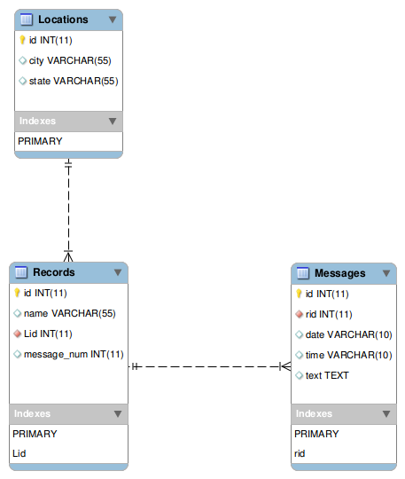

Figure

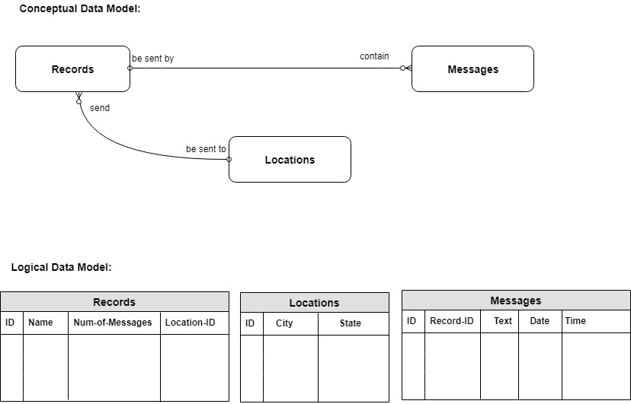

Figure